# Meeting of the Interim Services Australia Independent Advisory Board

Thursday 18 April 2024

Meeting for the fourth time, members of the Interim Independent Advisory Board explored two key matters:

* the application of automation in claims processing, and
* opportunities presented through the emergence of digital identity.

The Board members considered approaches to address the complex legislative, policy, implementation and people related matters in both these issues. This included methods of how these initiatives could be used support people who need access to government services.

In discussion with the Hon Bill Shorten MP, Minister for Government Services, the Board reflected on ways they can inform government thinking and innovation in the use of digital identity in practice to ensure service offers are useful, safe and coordinated.

Members were pleased to hear of progress made by Services Australia to continually strengthen the security of myGov, as well as the government services available in myGov, through the initial introduction of passkeys as a deterrent to phishing of credentials. With the technology new to government services, trialling this as a private beta will help shape readiness and approach to role this out for all myGov users.

Members also spoke with the Minister about other priority work being done in Services Australia to lift performance and enhance the customer experience. In particular the board contributed views on current efforts to apply automation to claims processing in a safe and ethical way. Further, the Board provided their support for efforts to introduce frameworks and lift staff capability to further build consistent service delivery across the agency’s extensive geographic and policy/program footprint.

Members also reflected on their experience on the Board to date, and canvassed some opportunities to ensure their advice remains useful, targeted and actionable.

## *Automation in Services Australia*

Members were briefed on automation as a critical enabler for the agency in delivering outcomes for customers, Services Australia staff, and government policy partners. They looked deeply at the agency’s approach to uplifting its automation capability, while acknowledging the challenges with respect to the increased use of automation in customer service delivery – including legislative constraints and rebuilding trust with the public.

The Board discussed how early sharing of the automation frameworks and uplifting capability in frontline community organisations is a critical part of ensuring that future automation provides intended benefits to people most in need of services and avoids unintended harm.

Members supported Services Australia’s automation future state and operating model and provided insights into how Services Australia can continue to evolve these. They supported the criticality of Services Australia’s use of automation to be ethical, legal, and transparent, and be designing in a human centred way to deliver better experiences for all Australians and Services Australia staff.

## *Joint session with the Digital ID Expert Panel*

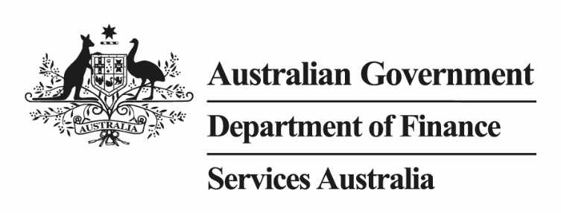

Members of the [Digital ID Expert Panel](https://www.linkedin.com/posts/katy-gallagher-310590293_digitalid-innovation-digitaltransformation-activity-7122098599827542016-Do0s) and the [Interim Independent Advisory Board](https://ministers.dss.gov.au/bill-shorten/advisory-boards) gathered in Melbourne for a collaborative discussion of opportunities to lift government service delivery and citizen experience through the Digital ID program.

Members engaged with officials from the Department of Finance, Australian Taxation Office and Services Australia to understand the whole of economy scope of the program and explore emerging approaches being considered by government.

The discussion brought together the Expert Panel’s commitment to supporting a Digital ID system that is secure, voluntary, convenient, and inclusive, with the Advisory Board’s deep expertise on trust and ethics in digital—including myGov—and other service channels.

Recognising that Australia’s future Digital ID system needs to support government service delivery and the broader digital economy, members provided insights on driving forward the Digital ID program in a safe and comprehensive way, considering issues such as privacy, accessibility, regulation, inclusion strategies and consumer choice and experience.

There was a strong recognition the cooperative approach between the bodies could assist both Senator the Hon Katy Gallagher and the Hon Bill Shorten MP in a shared agenda to modernise, enhance and secure government digital service delivery—including in the emerging area of verifiable credentials and digital wallets.

Collaboration between the expert groups has been facilitated by the shared Chair of the two fora, Victor Dominello. The Expert Panel and Advisory Board undertook to continue their discussion and promote the opportunities identified today through their ongoing advocacy to government.